COS30043 Interface Design and Development, Swinburne University of Technology
Individual Report: OpenTexila
Chia Kar You (106214483) · Group G7 (with Aung Moe Thu and Show Wai Yan) · Live application: https://opentexila.site
Vue 3 frontend, role-based student management system. Advanced feature: admin drag-and-drop weekly timetable with draft management, undo/redo, conflict detection and batch save.

1. Contributions
I built the frontend for the pages below. Each entry names the commit and main files in the frontend repository. Test counts are the number of test cases I added in the same commits.
Area / page | What I built | Key files and commits
Admin timetable (advanced feature, Section 2) | Weekly grid, session cards, move dialog, draft state, undo/redo, conflict warnings, batch save | src/features/scheduling/ (TimetableGrid.vue, SessionCard.vue, AdminTimetablePage.vue, use-timetable.js, schedule-conflicts.js, timetable-service.js); ee3e6f3, bd15162, 276e989, d0f8079; 38 tests
Login page | Validated sign-in form with loading state and mapped error messages (401, 403, 422, expired CSRF), later a styling pass on the card | features/auth/pages/LoginPage.vue, use-login.js, login-validation.js, jwt-session-adapter.js; 1538842, 2e2aeda
Forced password change | "Activate" page shown at first sign-in, with the router guard that locks the user to it until the password is changed | ChangePasswordPage.vue, change-password-validation.js, router/access.js, api-client.js; c6b116f; 18 tests
Student home page | Today's classes with in-progress status, check-in link and quick-access cards | features/dashboard/pages/StudentHomePage.vue; d075a54
Student "My classes" | Enrolled-class cards with course/term filters and pagination | StudentClassesPage.vue, StudentClassCard.vue, ClassPagination.vue, use-student-classes.js, student-classes-query.js; 078e889; 21 tests
Student attendance history | Paginated history list with class filter and loading / empty / no-match / error states | AttendanceHistoryPage.vue, attendance-query.js; 21350e4; 4 tests
Admin enrolments | Class list and per-class roster page (add and remove students) | AdminClassListPage.vue, AdminClassEnrolmentsPage.vue, enrolments-management-service.js; f31c412; 4 tests
Some of these pages were edited after my commits: the student home section order was changed by Aung Moe Thu, and the history filter was improved by Show Wai Yan. The geofence map editor and the attendance analytics are their features and are not claimed here.

2. Advanced feature: drag-and-drop timetable with drafts, undo/redo and conflict detection

2.1 What it is and why I chose it
The admin Timetable page (/admin/timetable) shows one week of class sessions as a 30-minute grid, Monday to Sunday. An admin drags a session card by its handle to another slot, or uses the card's Move button to set an exact start and end time. Moves are not sent to the server immediately. They accumulate as a draft that the admin can undo, redo, discard or save in one batch.
Rationale. Before this page, rescheduling meant editing sessions one at a time on separate forms (class schedule page), where the admin could not see other sessions at the same time. A timetable is a spatial task: whether a move is sensible depends on what else is in that room, with that lecturer, at that time. A grid makes the whole week visible, and direct manipulation matches how people think about the task. The draft model matters because a reschedule changes what students see and where they must check in, so mistakes should be cheap to reverse and the admin should see problems before anything is saved. Neither drag-and-drop with a managed draft nor undo/redo was taught in class.

2.2 Techniques
The feature is split into layers so that the rules can be tested without a browser.
- Drag and drop with vuedraggable. The grid (TimetableGrid.vue) wraps a vuedraggable component (Vue 3 binding of SortableJS) around each day/slot cell. Every cell is its own drop zone in one shared group, sorting inside a cell is turned off, and a :move callback rejects drops on past slots or on locked sessions. The cell carries its start time in a data-start attribute so that the callback can validate the target:
<draggable :model-value="sessionsForSlot(day, slot)" item-key="key"
:group="{ name: 'timetable-sessions', pull: true, put: true }"
:sort="false" :move="canDrag" handle=".session-drag-handle"
:force-fallback="true" :data-start="slotDate(day, slot.minutes).toISOString()"
@change="(event) => handleDrop(event, day, slot)">

handleDrop converts the target cell to an ISO time and emits move-session. The grid never mutates its props, so the draft stays the single source of truth. A card is positioned by its real start and duration (cardStyle), so a 2-hour class is twice as tall as a 1-hour class, and overlapping sessions are placed in side-by-side lanes by a sweep over the sorted entries (daySegments). Day columns widen automatically when a day has many lanes.
- Draft state and undo/redo as a composable. useTimetable() (composables/use-timetable.js) keeps an originalSessions baseline and a draftSessions copy, both in shallowRef, with undoStack and redoStack arrays of snapshots capped at 50 (HISTORY_LIMIT). A move first pushes a deep copy onto the undo stack and clears the redo stack; undo and redo swap snapshots between the two stacks. Everything the interface needs is derived with computed:
const conflicts = computed(() => findScheduleConflicts(draftSessions.value));
const changes = computed(() => draftSessions.value.filter(s => original && !sameTimes(original, s)).map(...));
const isDirty = computed(() => changes.value.length > 0);
const canSave = computed(() => isDirty.value && conflicts.value.length === 0);

Only sessions whose times differ from the baseline appear in changes, so moving a card away and back leaves nothing to save. moveSession preserves the session duration and the "late after" offset when dragged, accepts a custom end time from the Move dialog, and returns { success, message } instead of throwing, so the page can show the reason in an alert.
- Conflict detection as pure functions. utils/schedule-conflicts.js holds pure functions with no Vue imports. findScheduleConflicts compares every pair of non-cancelled sessions, tests overlap with start < otherEnd && otherStart < end (so back-to-back sessions are allowed) and reports a conflict of type class, lecturer or room (room labels compared case-insensitively). isSessionEditable and validateSessionTimes enforce that only future, scheduled sessions can move and that the late threshold lies inside the session. Because conflicts are a computed over the draft, every drag, undo or redo updates the warnings immediately. Conflicting cards turn red with a message ("Lecturer clash"), a summary banner lists them, and Save is disabled until they are resolved.
- Batch save with defensive checks. prepareSave() re-checks the draft and returns a payload containing only changed sessions. timetable-service.js validates the 1 to 100 changes (unique IDs, valid ordered times), sends one PATCH /class-sessions/batch, and checks the shape of the response before the page accepts it. After success the page rebuilds the baseline from the response and refetches the week. If the refetch fails it reports "Changes were saved, but the timetable could not be refreshed" rather than a false failure. Loading a week uses an AbortController so that a quick click through several weeks never shows a stale response.
- Protecting unsaved work. AdminTimetablePage.vue registers onBeforeRouteLeave and a beforeunload listener while the draft is dirty, and asks before changing week or discarding. Ctrl/Cmd+Z and Ctrl/Cmd+Y (or Shift+Z) trigger undo and redo, ignored while typing in form fields.
- Non-drag alternative and accessibility. Dragging is mouse and touch only, so every editable card has a labelled Move button (aria-label="Move COS30043 section A") that opens a modal dialog (role="dialog", aria-modal, labelled by its title, Escape closes it) with date and time inputs that go through the same moveSession rules. Status messages use role="status" and conflicts use role="alert".
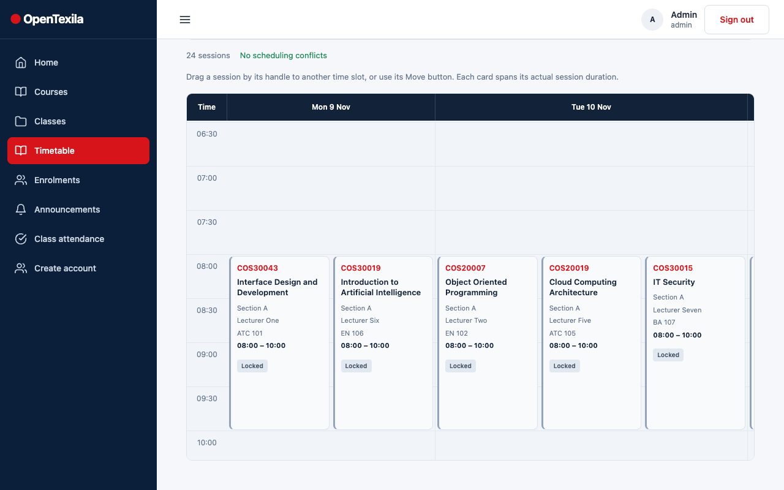 | 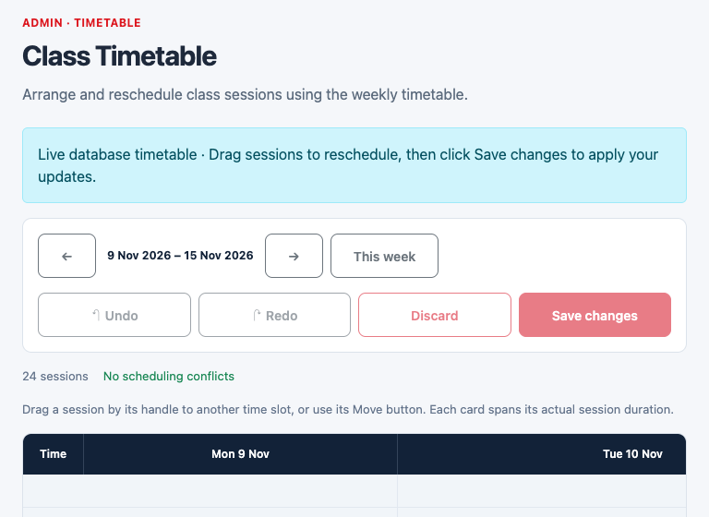
Figure 1. Timetable on desktop (left; the sessions shown are in the past, so they are marked "Locked") and tablet (right) with the Undo, Redo, Discard and Save changes toolbar and the conflict status line.

2.3 Testing and effect on the app
The conflict rules and the composable are the part most likely to break silently, so I wrote them first and tested them in isolation with Node's test runner: 18 cases for schedule-conflicts.js (each conflict type, adjacent sessions, cancelled sessions, started sessions, invalid times) and 20 for use-timetable.js (duration preserved, no mutation of the input, redo cleared by a new move, the 50-step limit, discard, refusing to save with conflicts, only changed sessions in the payload). These tests were useful again when I replaced the original mock-data version with the real API in d0f8079, because the composable's behaviour stayed the same while its data source changed. The feature turns a slow, form-by-form task into a single visual, reversible one, and the conflict warnings prevent double-booked lecturers and rooms before they reach students.

3. Other key techniques
- Feature folders and composables. Login, change-password and the student list pages follow the same split: a plain-JS validator or query builder (login-validation.js, change-password-validation.js, student-classes-query.js), a service for the API, a composable for state, and a thin page component. This is why these features have unit tests without mounting components.
- Request cancellation and explicit page states. use-student-classes.js aborts the previous request and ignores stale results with a request counter before updating classes, meta and error. The attendance history page uses a single state value (loading, ready, empty, no-match, error) so each case has its own message instead of a blank screen.
- Router guards. createAccessGuard in router/access.js redirects any user with must_change_password to the activate page and keeps them there, and redirects them home afterwards. The API client does not treat a wrong current password on /auth/change-password as an expired session, so the user stays on the form and sees the field error.
- Forms and responsive layout. Forms show an error under each field plus a general message, map server 422 field errors back onto the fields, clear the password after submit, and disable the button while loading. Pages use the shared design tokens and ot-* classes and Bootstrap grid breakpoints for phone, tablet and desktop.
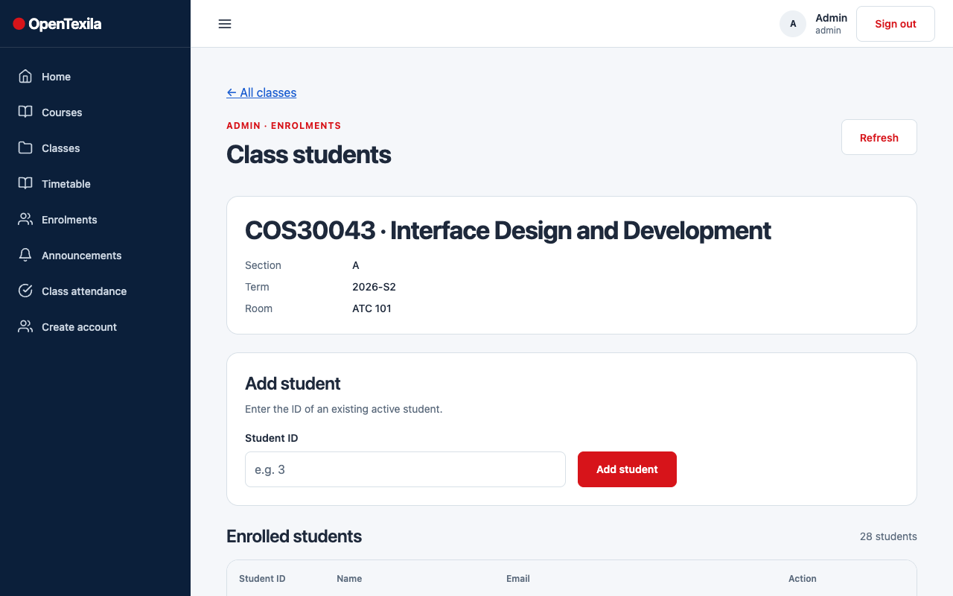 | 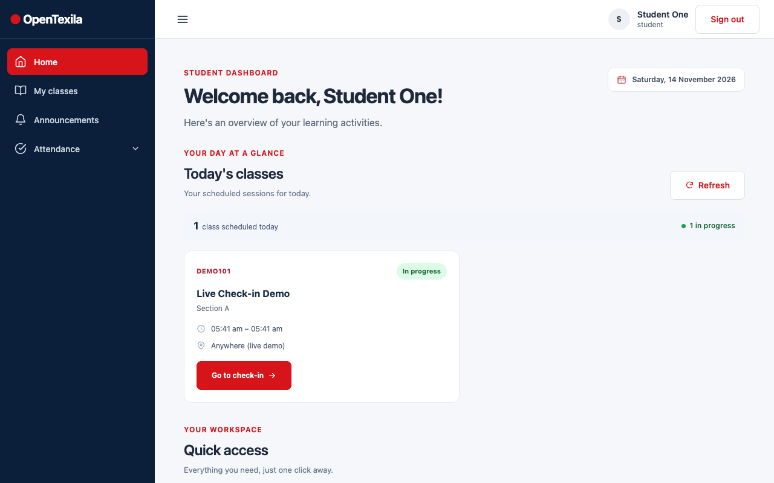
Figure 2. Admin class roster page (left) and student home page (right), both built by me.

4. Challenges and resolutions
- Drag-and-drop inside a scrolling grid. Sortable lists normally reorder items, but a timetable needs to place an item into a time cell. I used one draggable per cell with :sort="false", a :move guard, and force-fallback so the dragged card follows the pointer even inside the horizontally scrolling container. I only handle event.added, so the grid never writes to its own props.
- Time arithmetic and time zones. Sessions can start close to midnight and run past it, and the API uses UTC. The grid splits sessions into per-day segments with a "continuation" flag so they remain visible, and the page queries one extra UTC day on each side of the local week, then filters locally (comment in loadRealSessions). Moves keep duration and the late threshold, and validateSessionTimes rejects times in the past.
- Overlapping cards. Two sessions at the same time first drew on top of each other. The lane-assignment sweep fixed this, and widening the day column when there are many lanes kept each card readable, at the cost of horizontal scrolling.
- Moving from mock data to the real API. The first version (276e989) used local sample data. In d0f8079 I rewrote use-timetable.js and the page around the batch endpoint. The service validates every response and request, because a malformed response would otherwise corrupt the baseline and mark everything as changed. The failure case where the save succeeds but the refetch fails became a distinct warning message.
- Losing work by accident. Admins can lose a draft by changing week, reloading or following a link. The route-leave guard, beforeunload listener and the confirmation before week changes address this. The confirmation uses the browser's native window.confirm, which is simple and reliable but cannot be styled like the rest of the interface.
- Issues from testing that are still open. Group testing found that on narrow screens the 7-day grid needs horizontal scrolling (Figure 1, right; I considered this acceptable because each card must stay readable, but a day-by-day view on phones would be better), that a temporary authentication error appeared on one save attempt (the save is not retried automatically and the admin must press Save again; the error message is shown), and that the Move dialog closes on Escape only while keyboard focus is inside it. I did not add an explicit focus trap, so this is a known gap.

5. Reflection
The main lesson was to keep rules out of components. Because conflict detection and draft state are plain functions and a composable, I could change the drag library behaviour, the layout and the data source without rewriting the logic, and the tests caught mistakes early. If I had more time I would add a keyboard-only way to move a card between slots on the grid itself, a mobile day view, a focus trap in the Move dialog, and component-level tests for the grid, which currently has none (only the logic is tested). I would also make conflicts visible in the grid before a drop is committed, rather than only after it.

